Helpful windows to have open while working with Eclipse

1. At the top of Eclipse click Window -> Show View -> Other…

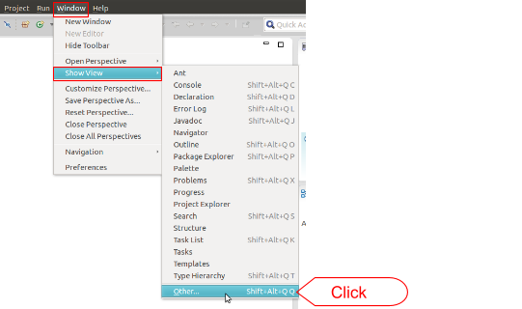

1. Under the Git folder choose “Git Repositories” and “Git Staging” and under the Team folder choose “History”. You will have to redo step 1 to open History window and Git Staging window.

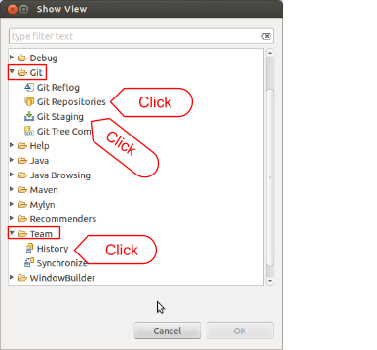

These windows are helpful for viewing past commits and versions of the project through the History window. Also with Git Repositories you can see what version you currently have open and easily make branches and switch to different branches to work on. Git Staging helps with merging branches.

Instructions for committing and pushing new changes

1. Once changes are made to a file , right click on the project name and go to Team → commit..

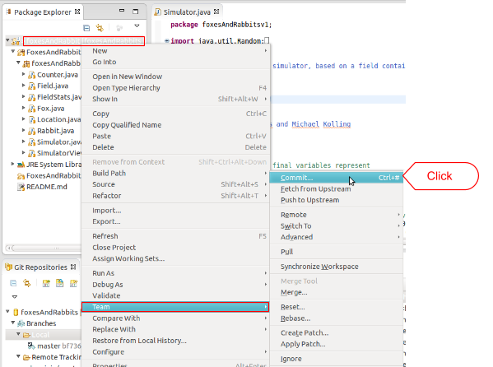

1. From here select the files you wish to commit and provide appropriate commit message

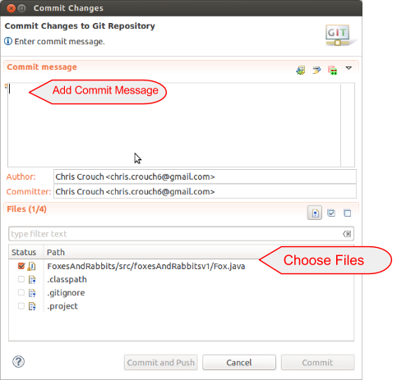

1. Click “Commit and Push” to commit changes and push the changes to the git repository
2. A window will open and ask for username and password for your github account. Fill in the fields and click “OK”

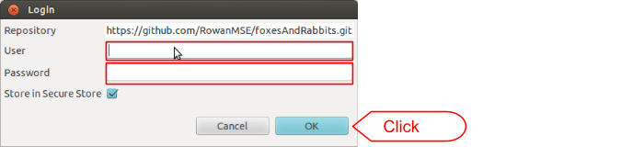

1. A window will appear with push results. Click “OK”

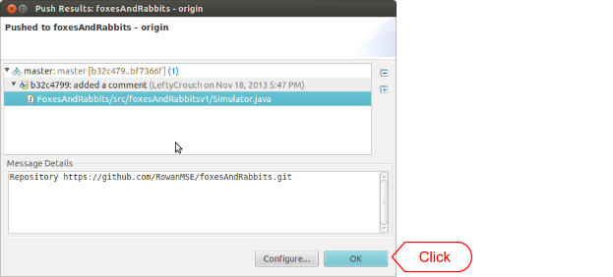

There are many other ways to commit changes. This is just one way. Also, you do not have to push changes to the server as soon as you commit. If, for example, you do not have internet access or just wish to wait, you can push your commits at any time after you commit them. They are saved locally until then.